GPGN490: Politics of Diversity
Professor Adida
Fall 2020

MW 12.30-1.50pm
Remote
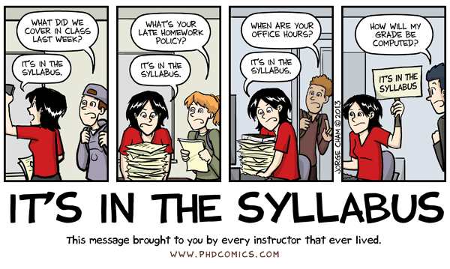

Introduction
This class seeks to answer a fundamental question for liberal democracies in an age of globalization: how do societies manage, and respond to, old and new forms of diversity?
Multiculturalism is a body of thought about how States respond to diversity. This class will introduce students to this body of thought, its main critiques, and its applications in the real world. It offers a theoretical and empirical overview, asking not just how States should respond, but how and why they do respond and what implications such responses have.
We will go back and forth between theoretical approaches to multiculturalism, empirical analyses of what works and what doesn’t work, and discussions of contemporary cases and debates.
You will hear from the experts themselves, researchers who have studied the impact of various policies and political actors on immigrant integration and minority wellbeing. You will also learn how the social sciences approach these questions in a way that allows (or doesn't allow) us to make causal claims, such as: "Policy X caused Y".
The lectures will be delivered synchronously via Zoom during our scheduled class time, Monday/Wednesday from 12.30 to 1.50pm. They will be recorded and uploaded to Canvas (it sometimes takes up to two days for lectures to post). I encourage you to attend the synchronous lectures if you can, where you will have opportunities to share your reactions to the class material and to ask questions. I will also stay for a few minutes after the end of lecture to answer any additional questions you may have.
However, I also understand that these are difficult times for many of us. There is of course no penalty for not attending classes synchronously, although everyone is expected to have completed the readings for the day before the beginning of class time, and everyone is expected to know the material covered in lecture and in the readings. Throughout the quarter, you can follow the class schedule and to-do's by clicking on the "Modules" tab on the left-hand side menu in Canvas.

Requirements
Class assignments are as follows:
- Quizzes (30%): I will assign regular quizzes to test your understanding of the readings. There are five quizzes throughout the quarter, each worth 6% of your total grade. These quizzes are to be taken on October 7 (Quiz 1), October 21 (Quiz 2), November 4 (Quiz 3), November 18 (Quiz 4), and December 2 (Quiz 5). They will be made available for you the entire day, for the full twelve hours. However, once you start the quiz, you will have only 15 minutes to complete it.
- Twitter thread (10%): Knowing how to write a good twitter thread can be a useful skill in this day and age. Select one of the Expert Q&As from class, and report on the research in a Twitter thread. Because the Q&As draw from the expert’s own work, I expect the Twitter thread to draw from both the Q&A video and the research itself. The thread should summarize the research’s main finding, convey why it is important, share one graph or visual you believe best conveys the work’s main contribution, and relate the research to current events (so a minimum of 4 tweets). You need not actually tweet it out, but you can. The assignment itself is due via Canvas on December 9 by 5pm.
- Discussions (30%): I will post four discussion topics throughout the quarter, and you will have to contribute to all of them. For each topic, you will receive half credit if you post a position (150-200 words) that is backed by either a cogent argument or social scientific evidence or both, and half credit for engaging constructively with your peers (50-100 words). Ad hominem attacks will not be tolerated.
- Final op-ed assignment (30%): Your final assignment is an op-ed (600 words max) that takes a position on a social, political, or cultural issue relating to multiculturalism. It should be backed not by your feelings or personal experience, but by social scientific evidence. We will discuss this assignment in greater detail in class. I have created a grading rubric in Canvas. Turn in your op-ed via Canvas by Monday, December 14, at 11.59pm.
Your final grade will be a letter grade following the below scale:
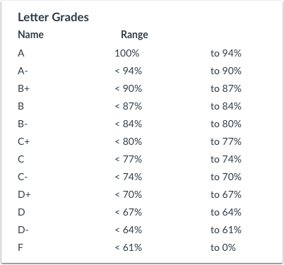
Format
The class meets synchronously as a zoom lecture twice a week for the ten weeks of the quarter. Your attendance is encouraged but not required. Whether or not you attend lectures synchronously, you are expected to complete the day’s readings before lecture starts; you are also expected to know the material covered in lecture by the end of that week. All lectures will be recorded and posted to Canvas. All readings and lectures are available on Canvas.
Student Accessibility
Students requesting accommodations for this course due to a disability must provide a current Authorization for Accommodation (AFA) letter issued by the Office for Students with Disabilities. Students are required to discuss accommodation arrangements with instructors and OSD liaisons in the department well in advance of any exams or assignments. The OSD Liaison for GPS is Nancy Gilson; please connect with her via ngilson@ucsd.edu as soon as possible.
Inclusive Classroom
Your TAs and I are fully committed to creating a learning environment that supports diversity of thought, perspectives, experiences, and identities. We urge each of you to contribute your unique perspectives to discussions of course questions, themes, and materials so that we can learn from them, and from each other. If you should ever feel excluded, or unable to fully participate in class for any reason, please let me know, or you may also submit feedback to Nancy Gilson (ngilson@ucsd.edu).
Additional resources to support EDI in our classroom, and beyond
- Office of Equity, Diversity, and Inclusion: 858.822.3542 | diversity@ucsd.edu
- Office for the Prevention of Harrassment and Discrimination: 858.534.8298 | ophd@ucsd.edu
- UCSD Office of the Ombuds: 858.534.0777
UCSD Academic Regulations and Policies
Each student is expected to abide by UCSD’s policy on Integrity of Scholarship and to excel with integrity in our course. Please also abide by UCSD’s Principles of Community and the Student Code of Conduct to support equity, diversity, and inclusion in our classroom.
Sexual Misconduct/Title IX Statement

UC San Diego prohibits sexual violence and sexual harassment and will respond promptly to reports of misconduct. If you wish to speak confidentially about an incident of sexual misconduct, please contact CARE at the Sexual Assault Resources Center at (858) 534-HELP. Students should be aware that faculty members are considered responsible employees and are not a confidential resource; as such, if you disclose an incident of sexual misconduct to a faculty member, they have an obligation to report it to UC San Diego’s Title IX office, the Office for the Prevention of Harassment & Discrimination (OPHD). To learn more about sexual misconduct, visit: https://students.ucsd.edu/sponsor/sarc/. To report an incident to the University, please contact OPHD at ophd@ucsd.edu

Contact
Zoom lectures: M/W 12.30-1.50pm: https://ucsd.zoom.us/j/98803892459
Professor Adida's OH: M 10am-12noon: https://ucsd.zoom.us/j/91258763648. Sign-up required here: https://calendly.com/cadida
ShahBano Ijaz’s OH: M 8-10am: https://ucsd.zoom.us/j/95262833770

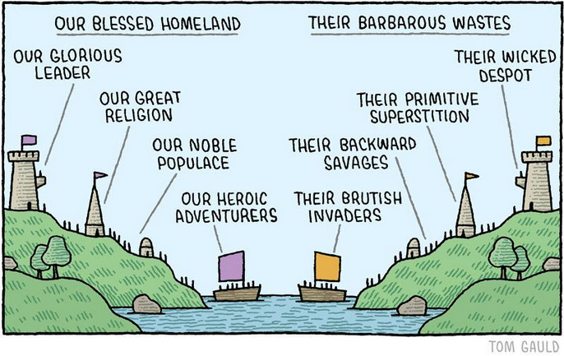
Week 1: What is multiculturalism?
We explore the theoretical concept of multiculturalism. We ask what it means, and examine the arguments for and against it. We discuss it in the context of gender equality.

October 5: Multiculturalism and its critics
- Kymlicka, W. 1995. Multicultural Citizenship. Chapters 1, 2 and 5.
- Barry, B. 2001. Culture and Equality: an Egalitarian Critique of Multiculturalism: Introduction.

October 7: Case study: gender equality and multiculturalism
- Okin, S. 1999. “Is multiculturalism bad for women?” in Is Multiculturalism Bad for Women?
- Parekh Bhikhu. 1999. “A varied moral world.” in Is Multiculturalism Bad for Women?
- Aala Abdelgadir and Vicky Fouka. 2020. “Secular policies and Muslim integration in the West: the effects of the French headscarf ban.” The American Political Science Review 114(3).
- Take Quiz 1 by midnight. Once you start you will only have 15 minutes to complete it.

Week 2: Race in the United States
We discuss the concept of race as a social construct, and how it has been understood over the years.

October 12: What is race? (Part I)
- Achenbach, J. 2009. “Study finds Africans more genetically diverse than other populations.” Washington Post.
- Kwame Anthony Appiah on race (2015): https://www.youtube.com/watch?v=EEOQcVLvnKo
- Kendi, Ibram. How to be an antiracist. Chapter 4

October 14: What is race? (Part II)
- Kendi, Ibram. How to be an antiracist. Chapter 5
- Watch PBS Documentary: “Race: the power of an illusion” Episodes 1 and 2

Week 3: Post-racial America?
We synthesize the ways in which African Americans face systematic discrimination in the US at various stages of their lives. We emphasize social science research that identifies a causal effect of race on discrimination.

October 19: Post-racial America? An overview of the evidence
- Bouie, J. 2015. “A tax on blackness.” Slate.com
- Clozel, L. 2014. “US schools plagued by inequality along racial lines, study finds.” LA Times.
- Oster, Emily: Racial disparities in COVID-19’s impact: https://covidexplained.org/other/racial-disparities-in-covid-19/

October 21: Post-racial America: the case of police violence
- Soss, J. and V. Weaver. 2017. “Police Are Our Government: Politics, Political Science, and the Policing of Race–Class Subjugated Communities” Annual Review of Political Science.
- West, J. 2018. “Racial bias in police investigation.”
- Knox, Dean and Jonathan Mummolo. 2020. “Toward a general causal framework for the study of racial bias in policing.” Journal of Political Institutions and Political Economy.
- Take Quiz 2 by midnight. Once you start you will only have 15 minutes to complete it.

Week 4: Political solutions to systemic racial discrimination? Affirmative action
Having established the prevalence of systemic racial discrimination, we discuss possible solutions, including affirmative action and material reparations for slavery.

October 26: Color-conscious vs. color-blind policies
- Amy Gutmann: Must Public Policy be Color Blind? in Appiah and Gutmann, eds. Color Conscious
- Elizabeth Anderson. The Imperative of Integration. Chapter 7.
- Discussion Topic 1 opens at 12am, closes October 30 at 11.59pm

October 28: Reparations and Affirmative action
- Coates, Ta-Nehisi. 2014. “The Case for Reparations.” The Atlantic.
- McWhorter, J. 2001. “Against Reparations.” New Republic.
- Khanna, G. 2020. “Does affirmative action incentivize schooling? Evidence from India.” The Review of Economics and Statistics

Week 5: Political solutions to systemic racial discrimination? Protest
Having established the prevalence of systemic racial discrimination, we discuss possible solutions, including protest.

November 2: Non-violent protest
- Chenoweth, E. and Stephan, M. 2016. "How the world is proving Martin Luther King right about nonviolence."
- Coates, T. 2015. "Nonviolence as compliance."
- Discussion Topic 2 opens at 12am, closes November 6 at 11.59pm

November 4: Violent protest
- Raven, R. 2013. "Black riot."
- Bassett, L. 2020. "Why violent protests work."
- Gause, L. 2020. "Black people have protested police killings for years. Here's why officials are finally responding."
- Wasow, O. 2020. "Agenda seeding: How 1960s Black protests moved elites, public opinion, and voting."
- Take Quiz 3 by midnight. Once you start you will only have 15 minutes to complete it.

Week 6: Introduction to Immigrant Integration
Through the lens of post-WWII immigrant integration policies in a couple European cases, we discover the key questions that shape the debates on immigration policy in industrialized democracies today.

November 9: What we learn from Europe
- Watch Rivers of Blood documentary
- Dancygier, R. Immigration and Conflict in Europe. Chapters 7 and 8.

November 11: Veterans’ Day (no class)

Week 7: Immigrant Integration in Europe
We learn about the assimilation vs. multiculturalism debate that has defined much of the academic scholarship and immigration policy regimes over the past few decades. We place this debate in the context of Muslim immigrant integration and its challenges.

November 16: Assimilation vs. Multiculturalism
- Bloemraad, I., Wright, M. 2014. “Utter Failure” or Unity out of Diversity? Debating and evaluating policies of multiculturalism.” International Migration Review 48(S1)
- Brubaker, Rogers. 2001. “The Return of Assimilation? Changing perspectives on immigration and its sequels in France, Germany, and the United States.” Ethnic and Racial Studies 24(4): 531-548.
- Kymlicka, W. 2010. “The rise and fall of multiculturalism? New debates on inclusion and accommodation in diverse societies.” International Social Science Journal 61.
- Discussion Topic 3 opens at 12am, closes November 25 at 11.59pm

November 18: Is there a Muslim disadvantage to immigrant integration?
- Adida et al. 2010. “Identifying barriers to Muslim integration in France.” PNAS
- Carens, Joseph H. 2000. “Muslim Minorities in Contemporary Democracies: The Limits of Liberal Toleration.” In Culture, Citizenship, and Community. New York: Oxford University Press, pp. 140-160.
- Maxwell and Bleich. 2014. “What makes Muslims feel French?” Social Forces 93(1).
- Take Quiz 4 by midnight. Once you start you will only have 15 minutes to complete it.

Week 8: Immigrant Integration in the US
We bring the debates on immigrant integration to the US context, with an overview of US immigration policy in historical perspective and the issues that motivate partisan polarization over immigration today.

November 23: Immigrant integration in the US
- Samuel P. Huntington. 2004. “The Hispanic Challenge.” Foreign Policy 141 (2): 30-45.
- Massey, Doug S. 2015. “The Real Hispanic Challenge.” Stanford University Pathways.
- Junn, Jane. 2007. “From Coolie to Model Minority.” Du Bois Review 4(2)

November 25: The Politics of Immigration in the US
- Wong, Tom. 2017. The Politics of Immigration. Chapter 2.
- Law, A.O. 2017. “This is how Trump’s deportations differ from Obama’s” Washington Post

Week 9: The nativist backlash
We explore the rise of populist politicians relying, successfully, on nativist messages in light of the immigration challenges discussed in previous weeks.

November 30: The nativist backlash
- Kai Arzheimer. 2009. “Contextual Factors and the Extreme Right Vote in Western Europe, 1980–2002.” American Journal of Political Science 53(2): 259-275.
- Mudde, Cas. 2012. “The relationship between immigration and nativism in Europe and North America.” Migration Policy Institute

December 2: The rise of Donald Trump: economic anxiety or identity politics?
- Tesler and Sides. 2016. “How political science helps explain the rise of Trump: white identity and grievances.” Washington Post.
- Gelman and Azari. 2017. “19 Things we learned from the 2016 election.” Statistics and Public Policy.
- Mudde and Kaltwasser. 2017. Populism: a very short introduction. Chapters 1 and 2.
- Take Quiz 5 by midnight. Once you start you will only have 15 minutes to complete it.

Week 10: Diversity in the time of COVID19
We consider what a global health pandemic has done to people’s attitudes toward migrants and minorities

December 7 Disease and migration: what we know from the Ebola crisis
- Adida, Dionne and Platas. 2020. “Ebola, elections, and immigration: how politicizing an epidemic can shape public attitudes.” Politics, Groups, and Identities 8(3).
- Campante, Depetris-Chauvin, and Durente. 2020. “The virus of fear: the political impact of Ebola in the US.” NBER Working Paper 26897.
- Discussion Topic 4 opens at 12am, closes December 11 at 11.59pm

December 9 Attitudes toward minorities in times of COVID
- Darling-Hammond et al. 2020. “After the `China Virus’ went viral: racially charged coronavirus coverage and trends in bias against Asian Americans.” Health Education & Behavior.
- Borja, Melissa. 2020. “The wounds of racism and the pandemic of anti-Asian hatred.” Patheos.
- Twitter thread is due via Canvas by 5pm

FINAL OP-EDs DUE: MONDAY, DECEMBER 14, 11.59PM
VIA CANVAS
