POLI108: Politics of Multiculturalism
Professor Adida
Winter 2025
PETER110
MWF 12-12.50pm

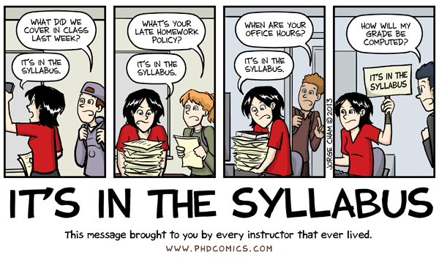

Introduction
This class seeks to answer a fundamental question for liberal democracies in an age of globalization: how do societies manage, and respond to, old and new forms of diversity? Multiculturalism offers a body of thought about how States should respond to diversity. This class will introduce students to this body of thought, its main critiques, and its applications in the real world. It offers a theoretical and empirical overview, asking not just how States should respond, but how and why they do respond and what implications such responses have.
We will go back and forth between theoretical approaches to multiculturalism, empirical analyses of what works and what doesn’t work, and discussions of contemporary cases and debates.
This class meets MWF from 12-12.50pm. We will meet in person on Mondays and Wednesdays. Most (but not all) Friday classes are reserved for practice quizzes, which will be made available only during class time. Lectures will be podcast and posted to Canvas. Attendance is strongly encouraged.
Requirements
Your performance in this class will be evaluated based on three types of assessments:
- Syllabus Quiz (15%): Many questions students have, are answered right here in this syllabus. You must take the syllabus quiz some time in the first three weeks of the quarter. You will no longer be able to take it after Sunday, January 26 at 5pm PST. This quiz is on PrairieLearn and lasts 45 minutes once it is started. You can only take it once and you must complete it once you start it. You cannot close it and get back to it later. The syllabus quiz is 10 questions long. Each question is worth 1.5 points. You get full credit if you get the answer right the first try, 1 point if you get it right the second try, 0.5 points if you get it right the third try, and 0 points after that.
- Practice Quizzes (25%): I will assign regular practice quizzes to help you prepare for your exams. These quizzes can be taken at any time during class time on the assigned Friday. They are open-notes, open-book, open-everything. They are meant to help you prepare for your exams, which will be closed-notes, closed-book, closed-everything. There will be five practice quizzes throughout the quarter, held during class time but remotely (via a link on Canvas) on: January 24, February 7, February 14, February 28, and March 7. These practice quizzes may be cumulative but they will focus on the most recent material (material between the last quiz and the current quiz). Each practice quiz is worth 5% of your grade. Practice quizzes will be graded based on correct answers and you will have the opportunity to earn half credit if you select the correct answer on the second try.
- Exams (60%): Three exams will be assigned in this course. These exams will be multiple choice, select all, and true/false. In fact, they will be very similar to your practice quizzes. These exams will be administered by the Triton Testing Center (TTC) in the Computer-Based Testing Lab in AP&M B349. There will be a testing window of four days for Exams 1 and 2 and six days for Exam 3 (the final exam). This allows for greater flexibility with your schedule. But as a result, you must schedule your tests in advance, and it is recommended that you do so as soon as possible.
  - Exam 1 (15%): The exam 1 window is January 29 to February 1. Exam 1 will be 45 minutes long and will cover material up to and including January 29.
  - Exam 2 (15%): The exam 2 window is February 19 to February 22. Exam 2 will be 45 minutes long and will cover material up to and including February 19. Yes, it is cumulative.
  - Exam 3 (30%): The exam 3 window is March 17 to March 22. Exam 3 will be 90 minutes long and will cover all the material from the entire quarter. Yes, it is cumulative.

Your final grade will be a letter grade following the below scale:
Letter Percentage equivalent
A 93-100
A- <93
B+ <90
B <87
B- <83
C+ <80
C <77
C- <73
D+ <70
D <67
F <60

Getting set up
- Three exams will be assigned in this course. These exams will be multiple choice, select all, and true/false. In fact, they will be very similar to your practice quizzes.
- These exams will be administered by the Triton Testing Center (TTC) in the Computer-Based Testing Lab in AP&M B349. There will be a testing window of four days for Exams 1 and 2, and 6 days for Exam 3. This allows for greater flexibility with your schedule. But as a result, you must schedule your tests in advance, and it is recommended that you do so as soon as possible.
- To schedule your exam, follow the below instructions:
  - Go to PrairieTest: https://us.prairietest.com/pt/login
  - Click the “Sign in with PrairieLearn”
  - Click “Join POLI 108”
  - Click the Green “Make a reservation” button
  - Choose a time slot for your exam
  - Click “Reserve this session”
- IMPORTANT: this test must be completed in-person at TTC - AP&M B349. You can make, change, or delete a reservation up to 10 minutes before your reservation begins.
- If you plan to use OSD-approved accommodations for your test, you will take it at the TTC’s Pepper Canyon Hall location. You must schedule your test at least three days in advance through the RegisterBlast system.
- If you have any questions, please reach out to at the TTC’s Virtual Front Desk or by email.
Expectations

- The class meets three times a week for the ten weeks of the quarter. Most Friday meetings, except for weeks 1 and 2, are reserved for remote assignments. You are expected to be available during class time on Fridays to complete your assignments. Just because we do not meet physically doesn’t mean this session doesn’t exist.

- Your exams are administered via the Triton Testing Center on computers that allow only access to the exam. You must schedule your exam during the testing window provided. Do this early. You will be asked to hand your phone or any other device when you enter the facility. Additionally, each exam will consist of a random selection of questions I have prepared: no two exams are likely to be the same, though exams will have the same level of difficulty for everyone.

- You are expected to complete the day’s readings before lecture starts, whether or not you attend lectures; you are also expected to know the material covered in lecture by the end of that week. All readings and lecture slides are available on Canvas.
Resources to Support Student Learning (URLs are embedded)
- Library Help, eReserves and research tools.
- Writing Hub.
- Supplemental Instruction.
- Mental Health Services.
- Community Center.
Student Accessibility
Students requesting accommodations for this course due to a disability must provide a current Authorization for Accommodation (AFA) letter issued by the Office for Students with Disabilities. Students are required to discuss accommodation arrangements with me and our OSD liaison (Zain Sharifi: zasharifi@ucsd.edu) well in advance of any exams or assignments. Please connect with the OSD Liaison for the political science department via the Virtual Advising Center as soon as possible. More information about OSD accommodations can be found here.
Academic Advising
Students who have academic advising questions related to the Political Science major, should contact the department's Undergraduate Advisor, Zain Sharifi, via the Virtual Advising Center. Academic advising questions often include (but are not limited to): add/drop deadlines, course enrollment policies, planning major and minor requirements, quarter-by-quarter plans, department petitions and paperwork, and referrals to campus and student support services.
Inclusive Classroom
Your TAs and I are fully committed to creating a learning environment that supports diversity of thought, perspectives, experiences, and identities. We urge each of you to contribute your unique perspectives to discussions of course questions, themes, and materials so that we can learn from them, and from each other. If you should ever feel excluded, or unable to fully participate in class for any reason, please let me know, or you may also submit feedback to our Undergraduate Student Affairs Advisor, Zain Sharifi (zasharifi@ucsd.edu). Zain will bring these comments to my attention.
Additional resources to support EDI in our classroom, and beyond
- Office of Equity, Diversity, and Inclusion: 858.822.3542 | diversity@ucsd.edu
- Office for the Prevention of Harrassment and Discrimination: 858.534.8298 | ophd@ucsd.edu
- UCSD Office of the Ombuds: 858.534.0777
UCSD Academic Regulations and Policies
Each student is expected to abide by UCSD’s policy on Integrity of Scholarship and to excel with integrity in our course. Please also abide by UCSD’s Principles of Community and the Student Code of Conduct to support equity, diversity, and inclusion in our classroom.
Sexual Misconduct/Title IX Statement

UC San Diego prohibits sexual violence and sexual harassment and will respond promptly to reports of misconduct. If you wish to speak confidentially about an incident of sexual misconduct, please contact CARE at the Sexual Assault Resources Center at (858) 534-HELP. Students should be aware that faculty members are considered responsible employees and are not a confidential resource; as such, if you disclose an incident of sexual misconduct to a faculty member, they have an obligation to report it to UC San Diego’s Title IX office, the Office for the Prevention of Harassment & Discrimination (OPHD). To learn more about sexual misconduct, visit: https://students.ucsd.edu/sponsor/sarc/. To report an incident to the University, please contact OPHD at ophd@ucsd.edu

Food Support for Students
If you are skipping and stretching meals, or having difficulties affording or accessing food, you may be eligible for CalFresh, California’s Supplemental Nutrition Assistance Program, that can provide up to $292 a month in free money on a debit card to buy food. Students can apply at benefitscal.com/r/ucsandiegocalfresh.

The Hub Basic Needs Center empowers all students by connecting them to resources for food, stable housing and financial literacy. Visit their site at basicneeds.ucsd.edu.

Office Hours
Instructor OH:
Professor Adida: Wednesdays 9-11am. Sign up here.
Social Sciences Building 389
cadida@ucsd.edu

TA OH:
Kailen Aldridge: Wednesdays 11am-12noon, or by Zoom (email to set up)
Social Sciences Building 351
kaaldridge@ucsd.edu
Linnea Graham: Thursdays 10.30-12.30pm, or by Zoom (email to set up)
Social Sciences Building 323
ligraham@ucsd.edu

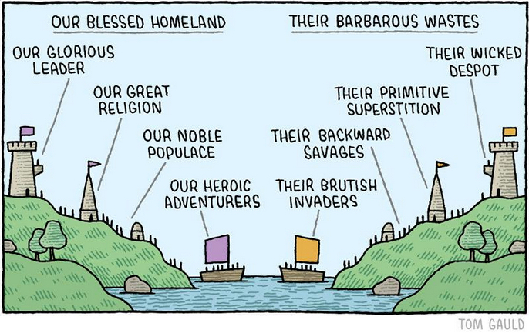
Date: Description | Assignments
Monday 1/6: Introduction; Multicultural claims | N/A
Wednesday 1/8: Multicultural claims | Read:  Stanford Encyclopedia of Philosophy entry on Multiculturalism
Friday 1/10: Multicultural justifications, Part I | Read:  Kymlicka 1995: chapter 5
Monday 1/13: Multicultural justifications, Part II | Read:  Kymlicka 1995: chapter 5
Wednesday 1/15: Multiculturalism’s critics, Part I | Read:  Waldron
Friday 1/17: Multiculturalism’s critics, Part II | Read:  Coulthard 2014: Chapter 1  Okin 1999
Monday 1/20: MLK Jr. Day | No class
Wednesday 1/22: The Politics of US Immigration, Part I | Read:  Wong 2016: Chapter 1
Friday 1/24; Practice Questions 1 | PQ1
Sunday 1/26: Last day to take syllabus quiz | Syllabus Quiz deadline
Monday 1/27: The Politics of US Immigration, Part II | N/A
Wednesday 1/29: Language politics | Read:  Fouka 2023
Exam 1 window: 1/29-2/1 | Exam 1
Monday 2/3: Politics of the headscarf | Read:  Abdelgadir and Fouka. 2020
Wednesday 2/5: Empirical evaluation of multiculturalism | Read:  Bloemraad and Wright 2014  Brubaker 2001  Hedlund 2024
Friday 2/7: Practice Questions 2 | PQ2
Monday 2/10: Why we exclude, PART I (remote video lecture) | Read:  Adida 2021
Wednesday 2/12: Why we exclude, PART II | Read:  Adida 2021
Friday 2/14: Practice Questions 3 | PQ3
Monday 2/17: Presidents’ Day | No class
Wednesday 2/19: Exposure and exclusion | Read:  Enos 2014  Hangartner et al. 2018
Exam 2 window: 2/19-2/22 | Exam 2
Monday 2/24: Political backlash | Read:  Mudde 2012
Wednesday 2/26; No Class | Watch Rivers of Blood
Friday 2/28: Practice Questions 4 | PQ4
Monday 3/3: Inclusion through contact | Read:  Lowe 2018  Moussa 2020
Wednesday 3/5: Inclusion through exceptionalism | Read:  Alrababa’h et al. 2021
Friday 3/7: Practice Questions 5 | PQ5
Monday 3/10: Inclusion through empathy | Read:  Simonovits et al. 2017  Williamson et al. 2020
Wednesday 3/12: Final Review | Read:  Cadava 2023  Orth 2023: link
Exam 3 window: 3/17-3/22 | Exam 3

